

|  |
| --- |
| **RESEARCH ON**  **KENYA’S IT**  **EDUCATION: THE**  **CASE OF MORINGA**  **SCHOOL** |
|  |
| **October 20**  **Professional Practice 2**  **Authored by: Workshop4 Group5** |

**Group name: Hello World**

**Members:**

Aiqiao Li

Bowen Zhang

Shiyun Zhu

Xixiang Chen

Zichen Pang

u7190768

u7274475

u7041419

u7267141

u6836694

**Catalog**

Abstract 2

Problem Statement 2

Financial Problem 2

Infrastructure Problem 4

Privacy problem 4

Background 5

Solution 6

The solution for financial problem 6

The solution for infrastructure problem 7

The solution for the privacy problem 7

Business Model for Kenya's IT education institution 9

Conclusion 10

References 11

# Abstract

This project is helping education in Kenya and other countries in a similar situation to Kenya through ICT education schools called Moringa School, boost employment rates, and support local ICT development. We choose to use ICT education because ICT does not depend on geographical location and other factors; only base station information and computers are needed to form an industry chain, which is a promising approach for such countries. However, during the project implementation, we encountered financial problems, infrastructure problems, and privacy problems. To address these challenges, we collected data from official reports of Kenya, including the employment rate of young people, and developed corresponding solutions. As a result, these countries will have more ICT professionals, and the corresponding unemployment rate will be reduced, and the country's overall economy will be improved. In the future, governments or organizations can use our project in more developing countries to help them educate more technology talents to help the country develop rapidly.

# Problem Statement

Moringa School is a multi-disciplinary education institution focusing on ICT education based in Kenya. Though the school has gained significant progress and helped many of Kenya's students from different backgrounds fill the southern Africa employment market gap, it still faces difficulty inhibiting its development pace.

## Financial Problem

The main problem that Moringa School and their students are facing is the financial situation. In Kenya, the gap between the rich and the poor is enormous. According to the 2020 report from the Kenya national bureau of statistics, the latest Kenya's Gini coefficient was 0.485 in 2016, and the following graph shows the Lorenz curve (statistics, 2020). The curve is far away from the straight line, which means the inequality of wealth is significant.

Many students are still in poverty, and their families have no spare money to invest in education. Survival is still their primary problem. Furthermore, education loans and government funding are always not feasible. On one hand, the student does not have collateral to engage in the loan. On the other hand, the government is also under financial constraints.

Figure 1, Lorenz curve based on per capita expenditure (1994, 2005/06 and 2015/16)

## Infrastructure Problem

Kenya is still a developing country. The ICT infrastructure could be another important obstacle that prevents students from acquiring high-quality education. The statistical data shows that 21.5% of rural youth do not have a cellphone and 6.9% urban counterparts (Kaimenyi, 2020).

The students may not afford a cellphone or a performing computer for their ICT education course. Modern education methods like remote learning platforms, zoom, AI teaching helper tools are unavailable in Kenya. Even worse, many villages suffer electricity shortages and have no Internet access. All these problems need to be solved before promoting the Moringa School operation model.

## Privacy problem

In recent years, many countries have been developing and legislate to protect their citizens' data privacy, like GDPR in Europe. Kenya also has its own data privacy law. And Kenya's data protection Act (the "DPA") entered into force on November 25, 2019, which is based on European Union's GDPR. Therefore, when developing and promoting new ICT education operating model, governance and data privacy are very important and cannot be neglect. Especially for foreign education institutions, digital compliance is one of the critical factors to business success (Kaguru, 2021).

# Background

This section provides related data and information for the solution.

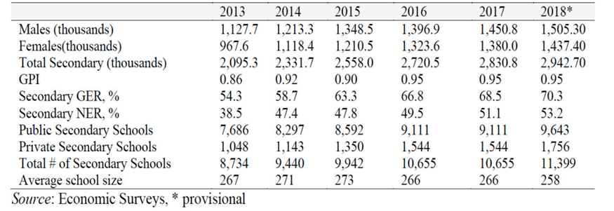There are three main reasons for the successful implementation of this project. First, The Kenyan government has given some policy support. For example, the Ministry of Education has announced annual funding of 5.4% of GDP for continuing education. They also enacted a five-year education plan named NESSP 2018-2022, which is in multiple sectors (Ministry of Education, 2018). The strategy will be implemented using a multi-sectoral approach involving all relevant parties. At the same time, many countries and institutions have offered Kenya grants and other help, such as Moringa School. Second, with the economic development of Kenya in recent years, Kenya has made significant progress in personnel education level and ICT infrastructure construction. Thanks to several undersea cables, Kenya's mobile Internet data speeds average 13.7 megabits per second. 3G coverage is about 85 percent, and 4G coverage is about 25 percent in Kenya (Many Possibilities, 2021).

Number of secondary school and students

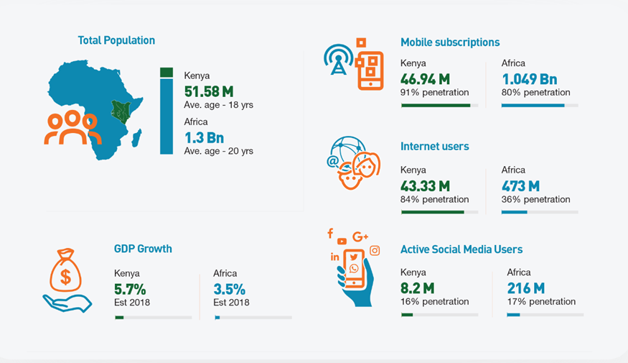Finally, according to the Ministry of Education report, the Kenyan government plans to increase ICT work for its government by at least 5%, providing many job opportunities for ICT talents. In addition, with the increasing exchanges 图示
between Kenya and the rest of the world, the number of ICT companies has increased recent years, and the number of jobs in the ICT industry has grown. Hiring local staff not only helps reduce the cost of employing ICT companies in Kenya but also helps lift Kenyans out of poverty.

(KENYA Mobile Report, 2019)

So Kenya is in an excellent position to start ICT education, which will also help local youth.

(Many Possibilities, 2021)

# Solution

## The solution for financial problem

For those poor people in Kenya, they cannot have enough chance to have well-education then they will be poor so that their kids might not have an opportunity to be well educated. Therefore, they need external help to break up a vicious development circle like financial support from the government or low-interest loans. In the beginning, to make sure that every student who has financial support can graduate and meet the job requirement, students must pass a standard test for participation. We provide three ways to support students who have no collateral to borrow money. The first one is the fund from the government. But the students need to sign a contract with the government that when they graduate from school and get a well-paid job, they need to provide a part of their salary into education funds to help other students who have financial problems or build more schools for basic education. This would help the government reduce funding pressure and create a virtuous circle of the educational development system. The second one is from business organizations. In this way, they need to sign a contract with the companies who support them that after they graduate from school, the graduates will work for the companies. The companies will deduct a portion of their salary to pay off the principal and interest on previous student loans. Companies and graduated students need feedback per month to ensure that their rights and interest are not violated. The third one is from charity or scholarship institutions. Students need to prove themselves how excellent they are, like the high GPA, the prizes, or the honor recognition, but it definitely is a pretty competitive way.

## The solution for infrastructure problem

At first, as we mentioned before, the students who pass the entrance examination can have financial support, so that it will provide enough money to help them come back to school to take the class. Unfortunately, during the covid-19 block down period, some students are confined to study at home. So, we provide several approaches for them. First, put the lecture and extra study materials on the internet like wattle and echo360 to help them access the information and catch up with the lecture. Second, for those students who cannot access computers, we can send them CDs or DVDs, any devices might help them study. Third, in the worst situation that they have no electric device, we can send them paper printings or books. But once they have the opportunity to come back to school, we will help them. After all, the most important thing for computer learning is practical training. Of course, the fundamental infrastructure and internet communication must be gradually built at the same time though it is a big time-consuming project.

## The solution for the privacy problem

In most developing countries, although they have laws to protect the privacy of the public on the internet, they do not have a good supervision system. Moreover, people whose privacy has been violated do not even know they have been violated. At first, internet privacy education and propaganda are necessary. Develops the internet privacy protection system well only after people know how important it is. The establishment of a system and the legislative process are both time-consuming, and while the priest climbs a post, the devil climbs ten, so we can use blockchain to ensure the security of their privacy. Only after getting the permission of students, the authorized organizations can use the individual information. The students even can use bio information to ensure the security of data.

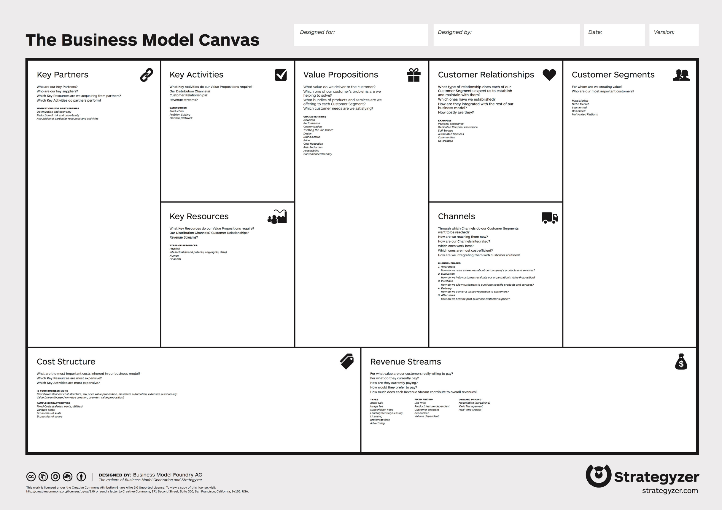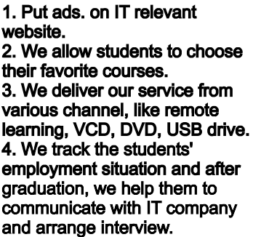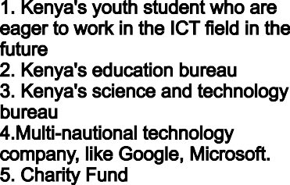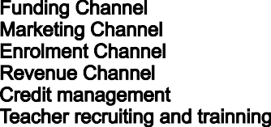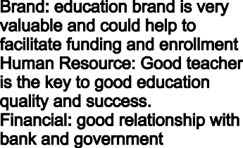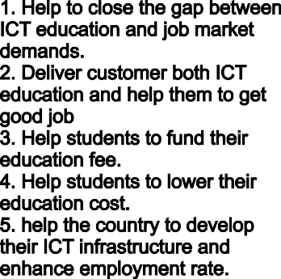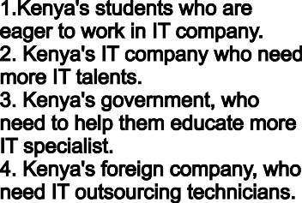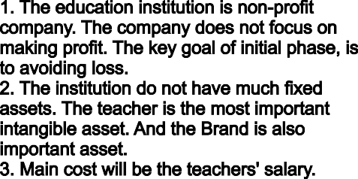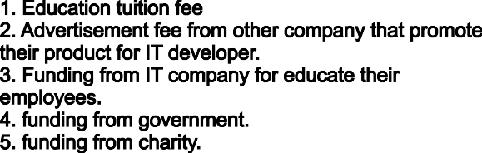

# Business Model for Kenya's IT education institution

# Conclusion

This paper takes Kenya as the research object and aims to explore the feasibility of ICT education in southern hemisphere countries similar to Kenya. The study found that countries in the southern hemisphere, similar to Kenya, generally faced three problems in carrying out the project: Financial difficulties, poor infrastructure, and privacy issues. This paper provides corresponding solutions to these three problems. Research has found that students can pay their tuition fees through government and corporate funding and pay back their original tuition loans on their wages once they find a job. Students can also learn through online education, and in extreme cases, schools will provide CDs and DVDs to ensure that students can keep up. At the same time, privacy courses are equally important, and schools need to make students aware of the specific definition of privacy and its boundaries.

Based on research and related data, this paper reasonably expounds on the feasibility of ICT education in countries in the southern hemisphere, aiming to provide help and guidance to target countries and related institutions on this project.

# References

Kaguru, J., 2021. *Recent developments on data privacy and protection in Kenya. [Online]   
Available at: https://www.jdsupra.com/legalnews/recent-developments-on-data-privacy-and-1051513/  
[Accessed September 29 2021].*

Kaimenyi, J. T., 2020. *Sector pan for science, technology and innovation,* Nairobi: Ministry of education, science and technology.

statistics, K. n. b. o., 2020. *Inequality trends and diagnostics in Kenya 2020,* Nairobi: Kenya national bureau of statistics.

Government of Kenya, 2018. Kenya Ministry of Education. *[Online]  
Available at: https://www.education.go.ke/  
[Accessed 2021].*

Government of Kenya, 2016.*Kenya Ministry of Education. [Online]  
Available at:  https://www.education.go.ke/index.php/programmes/digital-learning-programme  
[Accessed 2021].*

Many Possiilities, 2021. *african-undersea-cables. [Online]  
Available at: https://manypossibilities.net/african-undersea-cables/  
[Accessed 2021].*

Pauline Masese，Lilian Makena, 2019. *KENYA Mobile Report 2019. [Online]  
Available at: https://www.jumia.co.ke/sp-mobile-report/  
[Accessed 2021].*